**Expense Tracker Application - Phase 9: Reporting, Dashboards, and Security Review**

**Objective:** To analyze application data by building insightful reports and dashboards, and to conduct a final security review to ensure the application is secure, compliant, and ready for end-users.

**1. Build Key Reports**

**Purpose:** To create a series of reports to monitor spending, track the status of approvals, and identify expense patterns across the organization.

**Key Reports to Create:**

* **Expenses by Category:** Shows the total amount spent, grouped by category (e.g., Food, Travel).
* **Pending Approvals:** A list of all expense records currently awaiting manager approval.
* **Monthly Expense Trend:** A line report tracking the total volume of expenses submitted over time.
* **Employee Expense Summary:** Shows the total spending submitted by each employee.

**How to Create the 'Expenses by Category' Report:**

1. **Navigate:** Go to the **App Launcher** → **Reports** → **New Report**.
2. **Report Type:** Select the **Expenses** report type. (Note: If this is not visible, you may need to go to Setup → Object Manager → Expense, edit the object, and check "Allow Reports" ).
3. **Add Columns:** From the fields panel, add key columns to your report, such as Expense Number , Employee , Expense Date , Category , Amount , and Approval Status.
4. **Group Data:** Drag the Category field to the **Group Rows** section.
5. **Summarize Data:** On the Amount column, click the arrow and select **Summarize** → **Sum** .
6. **Set Filters:** In the **Filters** tab, set the Expense Date range to All Time or This Fiscal Year as needed.
7. **Save:** Click **Save & Run**. Name the report Expenses by Category and save it in a shared folder.

**Create a Custom Report Type (Optional):**

* **Purpose:** To create a report that links the Expense object to the User object, allowing you to include employee details (like their department, role, or manager) in the same report.
* **Navigation:** Go to **Setup** → **Report Types** → **New Custom Report Type**.
* **Configuration:** Set Expense as the Primary Object and relate it to the User (Employee) object.

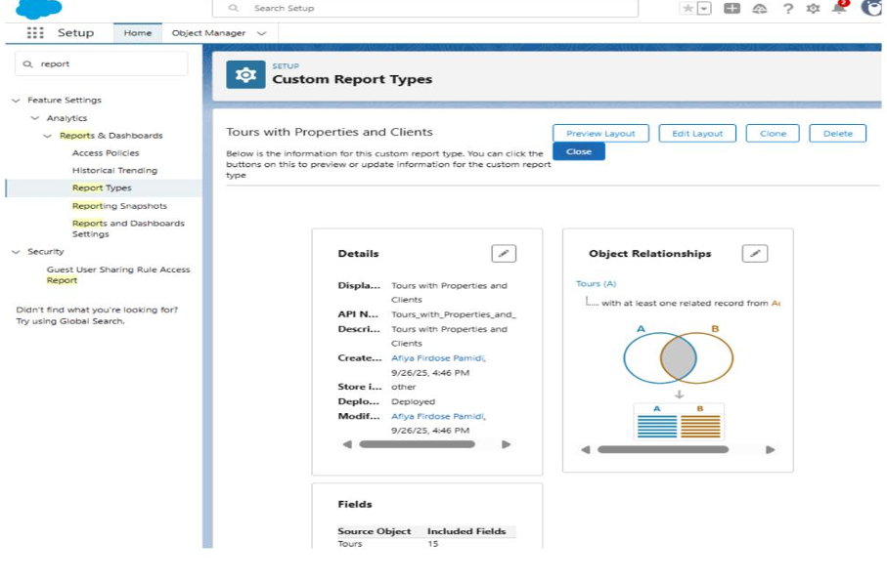

**2. Create the Expense Tracker Dashboard**

**Purpose:** To provide managers and executives with a quick, visual overview of key expense metrics, all in one place.

**Dashboard Creation Steps:**

1. **Navigate:** Go to the **Dashboards** tab and click **New Dashboard**.
2. **Name:** Give your dashboard a name, such as Expense Tracker Dashboard.
3. **Add Components:** Click **+ Component** and use the reports you built in the previous step:
   * Use the Expenses by Category report to create a **Pie Chart**.
   * Use the Pending Approvals report to create a **Table**.
   * Use the Monthly Expense Trend report to create a **Line Chart**.
4. **Arrange and Save:** Drag and drop the components to arrange your layout, then click **Save**.

**Advanced Feature: Dynamic Dashboards**

* You can set the dashboard to run as "The logged-in user". This ensures that managers only see data for their own teams, and employees only see their own expense data, all from the same dashboard.

**3. Conduct Final Security Review**

**Purpose:** To review and harden the security settings for the application, ensuring data is only visible to the correct users.

* **Organization-Wide Defaults (OWD):**
  + **Action:** Go to **Setup** → **Sharing Settings** and confirm that the Expense object's internal and external access is set to **Private**. This is the foundation of your security, ensuring users can only see their own records.
* **Field-Level Security (FLS):**
  + **Action:** Go to **Object Manager** → **Expense** → **Fields & Relationships**. For any sensitive fields (e.g., Manager_Comments ), click the field and **Set Field-Level Security** to hide it from profiles that should not see it, like a standard employee profile.
* **Login IP Ranges:**
  + **Action:** For high-security environments, go to **Setup** → **Profiles** and select a profile. Under **Login IP Ranges** , you can restrict users to only log in from trusted networks, like an office IP address.
* **Session Settings:**
  + **Action:** Go to **Setup** → **Session Settings**. Set the **Timeout Value** to a shorter duration (e.g., 30 minutes ) to automatically log out inactive users and reduce security risks.
* **Setup Audit Trail:**
  + **Action:** Go to **Setup** → **View Setup Audit Trail**. Regularly review this log to see who has made changes to your Salesforce configuration.

**Phase 9 Complete**

The Expense Tracker application is now fully equipped with analytical tools, allowing management to track spending and approvals. The security settings have been hardened to protect sensitive financial data, ensuring the application is compliant and secure. The project is now ready for end-user training and go-live.